Localization:
Localization means having a fairly accurate estimate of the robot’s state at all times with respect to its surroundings. Localization of the system is handled by fusing the data from different on-board sensors namely:GPS(Hemisphere AtlasLINK), IMU and feedback from wheel encoders. Sensor data as obtained from all the above mentioned sensors is fused to accurately determine the position, orientation as well as linear and angular velocity of the bot at all states.localization is handled independently from mapping without taking Lidar data into EKF module. Following the EKF process, the localization module takes sensor data to estimate the currentrobot state and performs prediction and correction steps based on the earlier and the latest robot states.

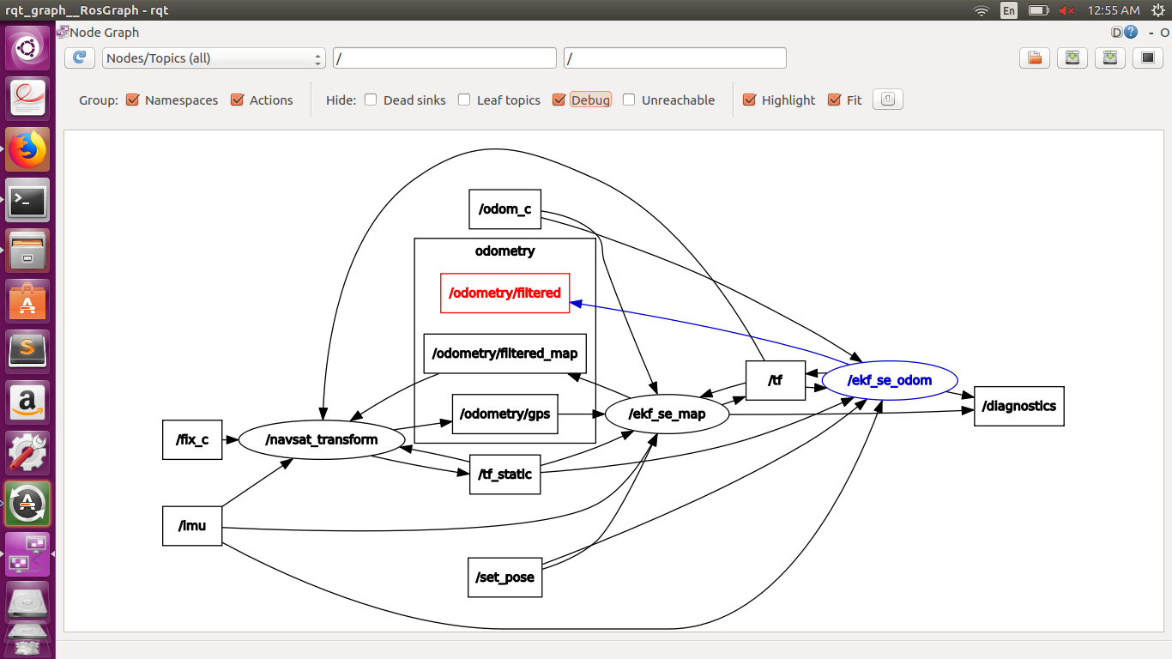
The localization package basically consists of 3 nodes -:- ekf_se_odom, ekf_se_map and navsat transform.
ekf_se_odom takes raw input as linear velocity and orientation from wheel encoders and linear acceleration and velocity yaw from IMU sensor. Using this, most accurate position of bot is estimated with respect to the odom frame(Published in odometry/filtered topic here). Along with this ekf_se_odom also publishes a transform from odom to base_link frame(child = base_link).
Two other nodes are used - ekf_se_map and navsat_transform.
Navsat_transform node takes input from imu sensor(/imu), odometry output(/odometry_filtered_map) as obtained from ekf_se_map node. navsat_transform node also publishes a transform(/tf_static) which tranforms from utm frame to map frame .
ekf_se_map node subscribes to /odom_c , /imu and /gps/filtered topics to obtain data from wheel encoders, IMU sensor. ekf_se_map node publishes filtered data(/odometry_filtered_map). ekf_se_map also publishes a transform from map to odom frame.
So finally, with all these 3 processes we get the most precise position of the bot in the odom frame that is obtained and also all the transforms that are requried (odom to base_link, map to odom, map to utm) . The reason that we require navsat_transform node and ekf_se_map frame is that the result obtained solely from the raw data obtained from imu and wheel encoders may be very much accurate, hence they can be used to estimate position of the bot for a short run but as the run becomes longer, error associated with due to drifting of the bot w.r.t the odom frame gets accumulated, hence there is a considerable shift in the estimated position of the bot w.r.t its original position, hence gps data is brought into use to serve this purpose i.e. to avoid long term continuous shifts in its position. Hence, it is fused with the GPS data via the ekf_se_map node which publishes transform from odom to map. Although, both odom and map frames are static frames, their transform from one to the other should also be constant but due to the continuous drift of the position of the bot, it is not constant.
Finally after running all these nodes the final result that was obtained :
Note : In the end, inaccuracy was around 60cm.
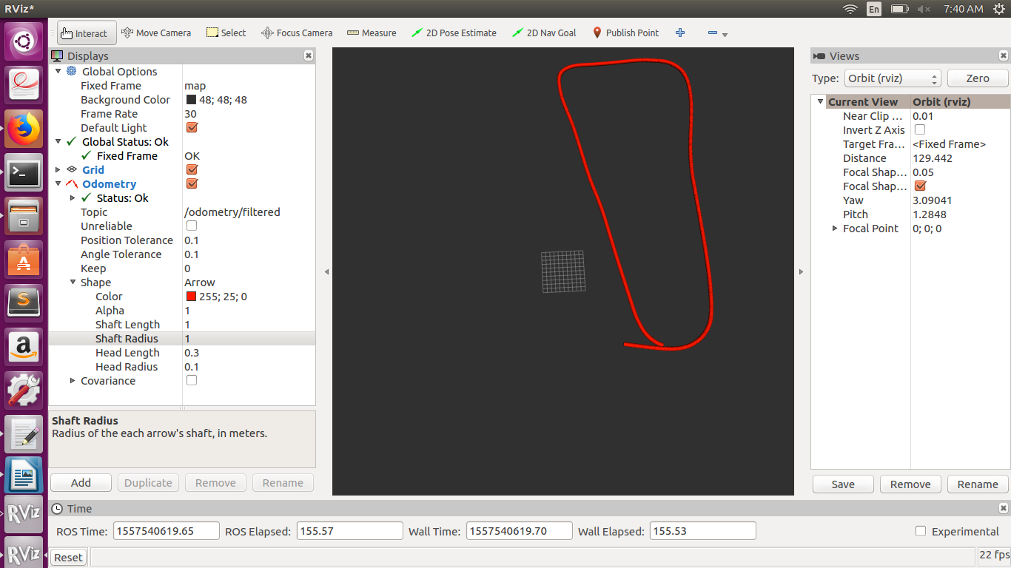
State transformation node:
1)ekf_localization_node (Read about ekf and ukf - SLAM course (Probablity) )
2)ukf_localization_node

Parameters Common to ekf_localization_node and ukf_localization_node:
1)~frequency
2)~sensor_timeout
3)~two_d_mode
4)~[frame]
Specific parameters:
- ~map_frame
- ~odom_frame
- ~base_link_frame
- ~world_frame
These parameters define the operating “mode” for robot_localization. REP-105 specifies three principal coordinate frames: map, odom, and base_link. base_link is the coordinate frame that is affixed to the robot. The robot’s position in the odom frame will drift over time, but is accurate in the short term and should be continuous. The map frame, like the odom frame, is a world-fixed coordinate frame, and while it contains the most globally accurate position estimate for your robot, it is subject to discrete jumps, e.g., due to the fusion of GPS data. Here is how to use these parameters:
- Set the map_frame, odom_frame, and base_link_frame parameters to the appropriate frame names for your system.
Note
If your system does not have a map_frame, just remove it, and make sure world_frame is set to the value of odom_frame.
- If you are only fusing continuous position data such as wheel encoder odometry, visual odometry, or IMU data, set world_frame to your odom_frame value. This is the default behavior for the state estimation nodes in robot_localization, and the most common use for it.
- If you are fusing global absolute position data that is subject to discrete jumps (e.g., GPS or position updates from landmark observations) then:
- Set your world_frame to your map_frame value
- Make sure something else is generating the odom->base_link transform. This can even be another instance of a robot_localization state estimation node. However, that instance should not fuse the global data.
The default values for map_frame, odom_frame, and base_link_frame are map, odom, and base_link, respectively. The world_frame parameter defaults to the value of odom_frame.

5)~transform_time_offset¶

6)~transform_timeout¶

7)~[sensor]¶

8)~[sensor]_config¶
Specific parameters:
- ~odomN_config
- ~twistN_config
- ~imuN_config
- ~poseN_config
For each of the sensor messages defined above, users must specify what variables of those messages should be fused into the final state estimate. An example odometry configuration might look like this:
<rosparam param="odom0_config">[true, true, false,
false, false, true,
true, false, false,
false, false, true,
false, false, false]</rosparam>
The order of the boolean values are X,Y,Z,roll,pitch,yaw,X˙,Y˙,Z˙,roll˙,pitch˙,yaw˙,X¨,Y¨,Z¨
. In this example, we are fusing X and Y position, yaw, X˙, and yaw˙
.
Note
The specification is done in the frame_id of the sensor, not in the world_frame or base_link_frame. Please see the coniguration tutorial for more information.

9)~[sensor]_queue_size¶

10)~[sensor]_differential¶
Specific parameters:
- ~odomN_differential
- ~imuN_differential
- ~poseN_differential
For each of the sensor messages defined above that contain pose information, users can specify whether the pose variables should be integrated differentially. If a given value is set to true, then for a measurement at time t
from the sensor in question, we first subtract the measurement at time t−1
, and convert the resulting value to a velocity. This setting is especially useful if your robot has two sources of absolute pose information, e.g., yaw measurements from odometry and an IMU. In that case, if the variances on the input sources are not configured correctly, these measurements may get out of sync with one another and cause oscillations in the filter, but by integrating one or both of them differentially, we avoid this scenario.
Users should take care when using this parameter for orientation data, as the conversion to velocity means that the covariance for orientation state variables will grow without bound (unless another source of absolute orientation data is being fused). If you simply want all of your pose variables to start at 0
, then please use the _relative parameter.
Note
If you are fusing GPS information via navsat_transform_node or utm_transform_node, you should make sure that the _differential setting is false.
11)~[sensor]_relative
Specific parameters:
- ~odomN_relative
- ~imuN_relative
- ~poseN_relative
If this parameter is set to true, then any measurements from this sensor will be fused relative to the first measurement received from that sensor. This is useful if, for example, you want your state estimate to always start at (0,0,0)
and with roll,pitch, and yaw values of (0,0,0). It is similar to the _differential parameter, but instead of removing the measurement at time t−1, we always remove the measurement at time 0, and the measurement is not converted to a velocity.
Note: Set publish_tf to true

ukf_localization_node
The parameters for ukf_localization_node follow the nomenclature of the original paper and wiki article.
- ~alpha - Controls the spread of sigma points. Unless you are familiar with unscented Kalman filters, it’s probably best for this setting to remain at its default value (0.001).
- ~kappa - Also control the spread of sigma points. Unless you are familiar with unscented Kalman filters, it’s probably best for this setting to remain at its default value (0).
- ~beta - Relates to the distribution of the state vector. The default value of 2 implies that the distribution is Gaussian. Like the other parameters, this should remain unchanged unless the user is familiar with unscented Kalman filters.

Published Topics
- odometry/filtered (nav_msgs/Odometry)
- accel/filtered (geometry_msgs/AccelWithCovarianceStamped) (if enabled)

Published Transforms
- If the user’s world_frame parameter is set to the value of odom_frame, a transform is published from the frame given by the odom_frame parameter to the frame given by the base_link_frame parameter.
- If the user’s world_frame parameter is set to the value of map_frame, a transform is published from the frame given by the map_frame parameter to the frame given by the odom_frame parameter.
Note
This mode assumes that another node is broadcasting the transform from the frame given by the odom_frame parameter to the frame given by the base_link_frame parameter. This can be another instance of a robot_localization state estimation node.

Services
- set_pose - By issuing a geometry_msgs/PoseWithCovarianceStamped message to the set_pose topic, users can manually set the state of the filter. This is useful for resetting the filter during testing, and allows for interaction with rviz. Alternatively, the state estimation nodes advertise a SetPose service, whose type is robot_localization/SetPose.

